**Shubham Garg**

**9919103057**

**F2**

**Assignment**

**(11 May-16 May,2020)**

**1.**

**#include<iostream>**

**#include<string.h>**

**#include<cstdio>**

**using namespace std;**

**class Inventory**

**{**

**public:**

**char author[50],title[80],publisher[50];**

**int price,no;**

**void getdata();**

**void display();**

**};**

**void Inventory::getdata()**

**{**

**cout<<"Enter the Author name:";**

**fflush(stdin);**

**cin.getline(author,100);**

**cout<<"Enter the Title of book:";**

**fflush(stdin);**

**cin.getline(title,100);**

**cout<<"Enter the Publisher of book:";**

**fflush(stdin);**

**cin.getline(publisher,100);**

**cout<<"Enter the Price of book:";**

**cin>>price;**

**cout<<"Enter the Number of books:";**

**cin>>no;**

**cout<<endl;**

**}**

**void Inventory::display()**

**{**

**cout<<endl;**

**cout<<"Author Name:"<<author<<endl;**

**cout<<"Title of Book:"<<title<<endl;**

**cout<<"Publisher:"<<publisher<<endl;**

**cout<<"Price of book:"<<price<<endl;**

**cout<<"Number of books:"<<no<<endl;**

**cout<<endl;**

**}**

**void compare(int n,Inventory t[])**

**{**

**int i,f=0,cp;**

**char tt[100],an[100];**

**cout<<"Enter the Author name:";**

**fflush(stdin);**

**cin.getline(an,100);**

**cout<<"Enter the Title of book:";**

**fflush(stdin);**

**cin.getline(tt,100);**

**for(i=0;i<n;i++)**

**{**

**if(strcmp(tt,t[i].title)==0 && strcmp(an,t[i].author)==0)**

**{**

**f=1;**

**t[i].display();**

**cout<<endl<<"Enter the required no. of copies:";**

**cin>>cp;**

**if(cp<=t[i].NB)**

**cout<<"Total cost books:"<<t[i].price*cp<<endl;**

**else**

**cout<<"Required copies not in stock"<<endl;**

**cout<<endl;**

**}**

**}**

**if(f==0)**

**cout<<"Book is not available!!!"<<endl;**

**}**

**int main()**

**{**

**int n,ch,i;**

**cout<<"Enter the number of Books in Inventory:";**

**cin>>n;**

**Inventory t[n];**

**for(i=0;i<n;i++)**

**t[i].getdata();**

**cout<<"Choices:-"<<endl;**

**cout<<"1. Book Required"<<endl;**

**cout<<"2. Display details of all books"<<endl;**

**cout<<"3. Exit"<<endl;**

**while(1)**

**{**

**cout<<"Enter your choice:";**

**cin>>ch;**

**switch(ch)**

**{**

**case 1:**

**compare(n,t);**

**break;**

**case 2:**

**for(i=0;i<n;i++)**

**t[i].display();**

**case 3:**

**break;**

**}**

**if(ch==3)**

**break;**

**i++;**

**}**

**return 0;**

**}**

**OUTPUT:-**

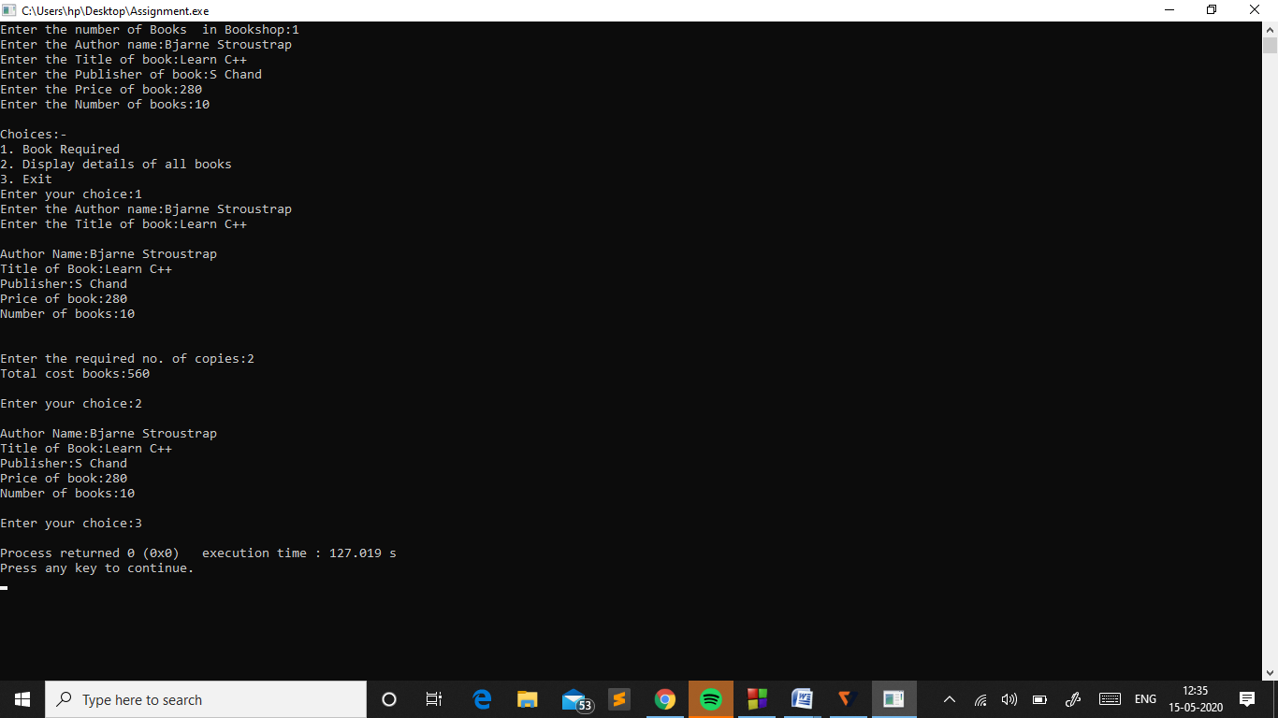

**2.**

**#include<iostream>**

**#include<string.h>**

**#include<cstdio>**

**using namespace std;**

**static int count=0;**

**class Employee**

**{**

**public:**

**char first_name[50],last_name[80];**

**int Monthly_Salary;**

**Employee()**

**{**

**count++;**

**strcpy(first_name,"FIRST NAME");**

**strcpy(last_name,"Last name");**

**Monthly_Salary=0;**

**}**

**void set()**

**{**

**cout<<"Enter First Name: ";**

**fflush(stdin);**

**cin.getline(first_name,100);**

**cout<<"Enter Last name: ";**

**fflush(stdin);**

**cin.getline(last_name,100);**

**fflush(stdin);**

**cout<<"Enter monthly salary: ";**

**cin>>Monthly_Salary;**

**cout<<endl;**

**}**

**void get()**

**{**

**cout<<"First Name: "<<first_name<<endl;**

**cout<<"Last Name: "<<last_name<<endl;**

**cout<<"Monthly Salary: "<<Monthly_Salary<<endl;**

**}**

**};**

**int main()**

**{**

**Employee e1,e2,e3;**

**cout<<"Enter details of First Employee"<<endl;**

**e1.set();**

**cout<<"Enter details of Second Employee"<<endl;**

**e2.set();**

**cout<<"Annual salary of first Employee is: "<<e1.Monthly_Salary*12<<endl;**

**cout<<”Annual salary of second Employee is: "<<e2.Monthly_Salary*12<<endl;**

**cout<<endl<<"After 10% rise "<<endl;**

**float a,b;**

**a=0.1*(float)e1.Monthly_Salary+e1.Monthly_Salary;**

**b=0.1*(float)e2.Monthly_Salary+e2.Monthly_Salary;**

**cout<<"First Employee Salary "<<a*12<<endl;**

**cout<<"Second Employee Salary: "<<b*12<<endl;**

**cout<<"Default objects are "<<count<<endl;**

**return 0;**

**}**

**OUTPUT:-**

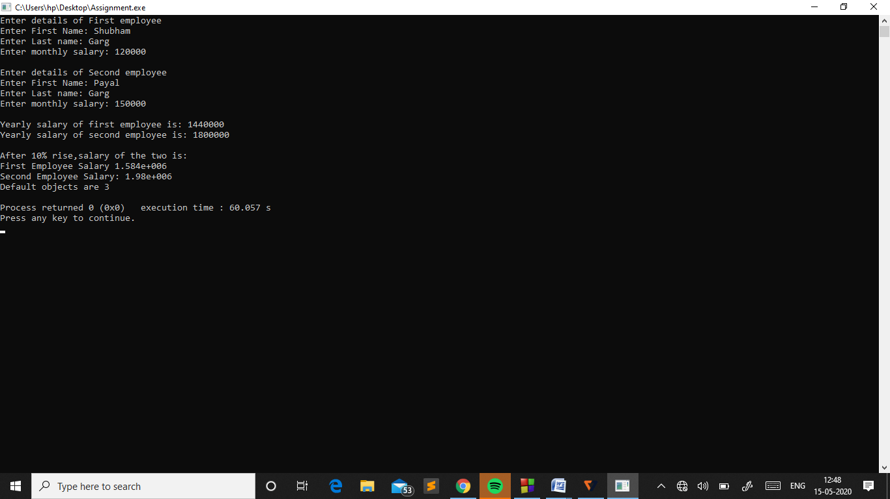

**3.**

**#include<iostream>**

**#include<string.h>**

**#include<cstdio>**

**using namespace std;**

**class Document**

**{**

**private:**

**string text;**

**public:**

**void settext(string);**

**string gettext();**

**void find_key();**

**};**

**string Document::gettext()**

**{**

**return text;**

**}**

**void Document::settext(string x)**

**{**

**text=x;**

**}**

**class Email:public Document**

**{**

**private:**

**string member,recipient,title;**

**public:**

**void setmember(string);**

**string getmember();**

**void setrecipient(string);**

**string getrecipient();**

**void settitle(string);**

**string gettitle();**

**};**

**string Email::getmember()**

**{**

**return member;**

**}**

**void Email::setmember(string x)**

**{**

**member=x;**

**}**

**string Email::getrecipient()**

**{**

**return recipient;**

**}**

**void Email::setrecipient(string x)**

**{**

**recipient=x;**

**}**

**string Email::gettitle()**

**{**

**return title;**

**}**

**void Email::settitle(string x)**

**{**

**title=x;**

**}**

**class File: public Document**

**{**

**private:**

**string pathname;**

**public:**

**void setpathname(string);**

**string getpathname();**

**};**

**string File::getpathname()**

**{**

**return pathname;**

**}**

**void File::setpathname(string x)**

**{**

**pathname=x;**

**}**

**void Document::find_key()**

**{**

**string f;**

**cout<<"Enter the keyword:";**

**cin>>f;**

**if(text.find(f,0)!=string::npos)**

**cout<<"Keyword is found"<<endl;**

**else**

**cout<<"Keyword is not found"<<endl;**

**}**

**int main()**

**{**

**Email Doc;**

**string s;**

**cout<<"Entry in email:-"<<endl;**

**cout<<"Enter Member name:";**

**fflush(stdin);**

**getline(cin,s);**

**Doc.setmember(s);**

**cout<<"Enter Recipient:";**

**fflush(stdin);**

**getline(cin,s);**

**Doc.setrecipient(s);**

**cout<<"Enter Title:";**

**fflush(stdin);**

**getline(cin,s);**

**Doc.settitle(s);**

**cout<<"Enter the Message:-"<<endl;**

**fflush(stdin);**

**getline(cin,s);**

**Doc.settext(s);**

**File f;**

**cout<<"Entry in File:-"<<endl;**

**cout<<"Enter Pathname:";**

**fflush(stdin);**

**getline(cin,s);**

**f.setpathname(s);**

**cout<<endl<<"OUTPUT:-"<<endl;**

**cout<<"Text:"<<Doc.gettext()<<endl;**

**cout<<"Member:"<<Doc.getmember()<<endl;**

**cout<<"Recipient:"<<Doc.getrecipient()<<endl;**

**cout<<"Title:"<<Doc.gettitle()<<endl;**

**cout<<"File Pathname:"<<f.getpathname()<<endl;**

**int ch;**

**cout<<"Choices:-"<<endl;**

**cout<<"1.Search"<<endl;**

**cout<<"2.Exit"<<endl;**

**while(1)**

**{**

**cout<<"Enter the choice:";**

**cin>>ch;**

**switch(ch)**

**{**

**case 1: Doc.find_key();**

**break;**

**}**

**if(ch==2)**

**break;**

**}**

**return 0;**

**}**

**OUTPUT:-**

